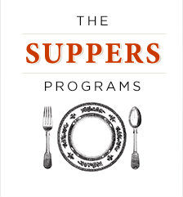

When the food is delicious, do you get happy? When it’s delicious and healthy,
do you feel like celebrating? If so, please join us for

(Name of your group here)
A new Suppers meeting in (name of town)

The Suppers Programs will bring a new meeting to (town) this (fall/winter/spring/summer).
For those of you who don’t know the program, Suppers is a network of groups made up of people who have all kinds of reasons to want to prepare delicious, healthy meals and eat them together.
We run mostly out of private homes, and the meetings are run by trained, volunteer facilitators.
It is nearly free to users, you just cover the shared cost of the meal.

This new Suppers meeting (describe what makes this meeting special) . . .

The meetings will be run by (your name). (Her/His) background (add your details here) . . .

Please email or call if you would like to be on the invitation list. The first meeting will be on (add date/time here).
Facilitator name
Phone number
Email address
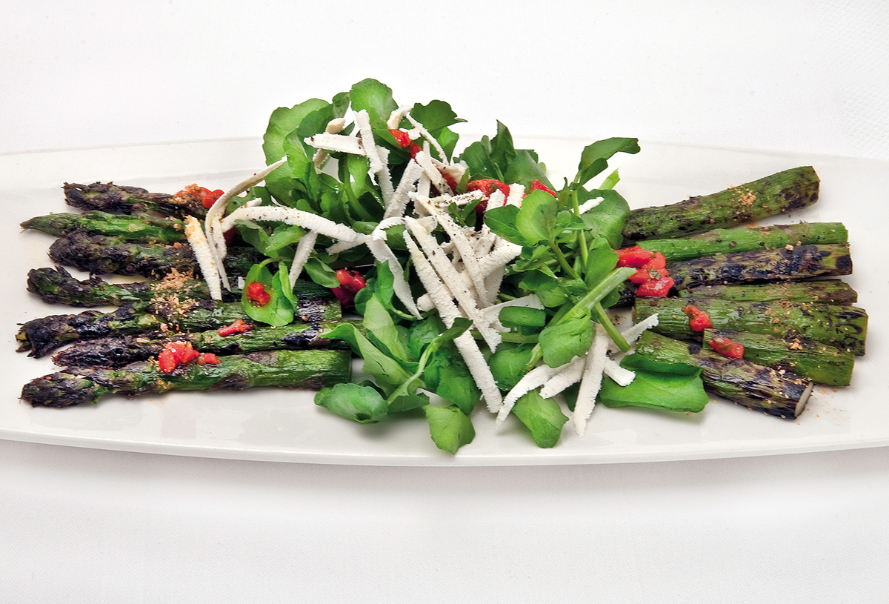
www.TheSuppersPrograms.org

